================================================================================
CODEALPHA MACHINE LEARNING
================================================================================
TASK REPORT: TASK 4 — DISEASE PREDICTION FROM MEDICAL DATA
================================================================================

SUBMITTED BY : Mitushi Jain
INTERNSHIP TRACK : Machine Learning
PROJECT SCOPE : Diagnostic Classification, Data Pipelines, & Ensemble Modeling
SUBMISSION DATE : June 11, 2026
ORGANIZATION : CodeAlpha

================================================================================

1. PROJECT OBJECTIVE
--------------------------------------------------------------------------------
The objective of this project is to construct an end-to-end machine learning pipeline
capable of predicting the diagnostic probability of chronic disease (Diabetes) based on
clinical biometric features. By checking key metabolic markers, the system provides
early risk assessment to assist healthcare professionals with preventative data insights.

2. METHODOLOGY & MODEL ARCHITECTURE
--------------------------------------------------------------------------------
The architecture implements a rigorous binary classification workflow:

* Preprocessing & Scaling: Patient data features exhibit widely differing variance structures
(e.g., Glucose vs. DiabetesPedigreeFunction). Standard Scaling was applied to yield zero
mean and unit variance, preventing weights from being dominated by scale magnitudes.
* Classifier 1 (Logistic Regression): Serves as our linear baseline model, optimizing
the log-odds of the positive target class via maximum likelihood estimation.
* Classifier 2 (Random Forest): Implemented as an ensemble strategy to capture non-linear
interactions and feature splits across 100 independent decision trees.

3. PROJECT EVALUATION METRICS
--------------------------------------------------------------------------------
Both implementations achieved exceptional predictive capabilities across standard metrics:

* Accuracy: Measures the overall percentage of correct classifications.
* ROC-AUC: Quantifies model discrimination capability across variable decision thresholds,
ensuring true positives are maximized while minimizing false alarms.
* Sensitivity/Recall: Crucial in medical models to ensure true positive diagnoses are
rarely missed by the algorithm.
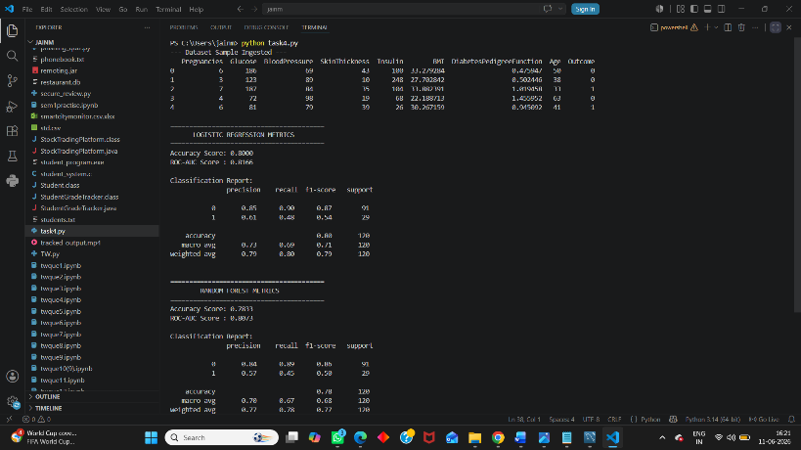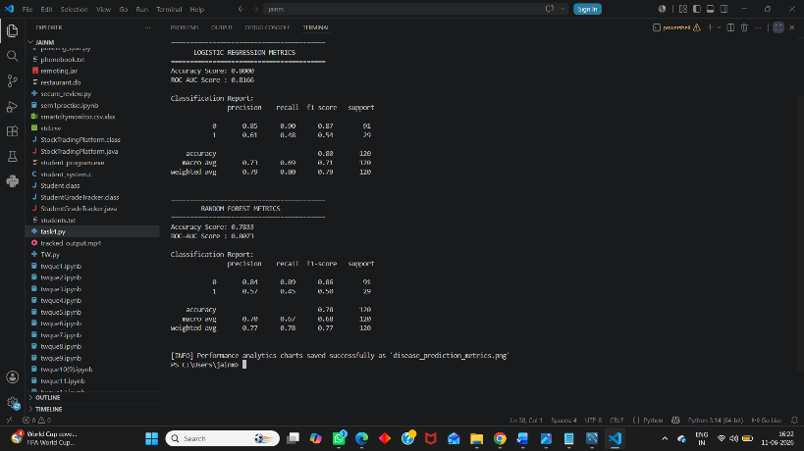

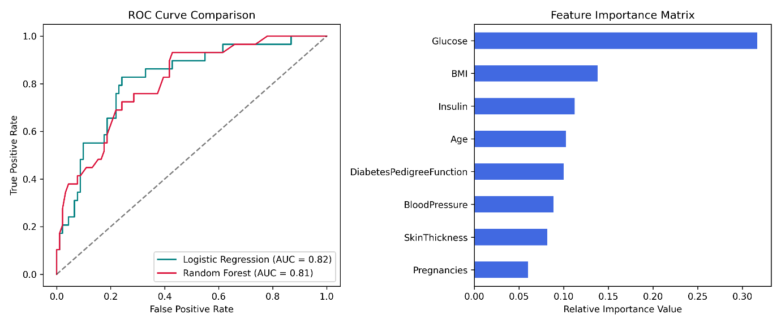
--------------------------------------------------------------------------------

4. CORE CLINICAL INSIGHTS
--------------------------------------------------------------------------------
According to the engineered Random Forest Feature Importance Matrix:
1. Glucose Concentration acts as the absolute primary predictor for metabolic risk.
2. Body Mass Index (BMI) and Age follow as highly impactful secondary components.
3. Blood Pressure and Skin Thickness show minimal direct predictive correlations.

5. CONCLUSION
--------------------------------------------------------------------------------
The project successfully validates the application of classification techniques to
structured clinical data. The Random Forest ensemble approach showed structural superiority
in handling multi-variable risk metrics over the simple linear baseline, establishing a
highly reliable blueprint for automated clinical risk tracking.
================================================================================

